Home Loan Management System
The Home Loan Management System is a full-stack web application designed to automate and simplify the complete lifecycle of a home loan—from user registration to final loan closure.
The system allows users to:
- Register and securely log in
- Create and manage a saving account
- Apply for a home loan based on salary eligibility
- Track loan status and repayment schedule
- Pay EMIs, make prepayments, or foreclose the loan
At the same time, an admin can:
- Review loan applications
- Approve or reject loans
- Monitor loan activities
Tech Stack:

Backend
- Spring Boot
- Spring Security
- Hibernate
- MySQL Database

Frontend
- React (Vite)
- Bootstrap

USER LOGIN FLOW:
Register/---- > User enters credentials (POST /auth/register)
{
“username”: "Jaggie",
“Email”: “jaggie027@gmail.com”
“password”: "1234"
}

Login ---- > User enters credentials (POST /auth/login)
{
"username": "Jaggie",
"password": "1234"
}
ADMIN LOGIN FLOW
Step-by-Step
Same flow as user, only difference = role = ADMIN
Step 1: Admin Login Request
-- > go to frontend register page and register via these credential or you can modify it ..
{
"username": "admin",
“Email” : “admin0026@gmail.com”
"password": "admin123"
}

Step 2: Backend Validation (Update the role in database)
- Go to the MySQL database
- Select the database(home_loan) to update the role
- Show tables < select * from users;
- Update the role for admin (because admin should be one) use this command
update users set role="ADMIN" where user_id=1;Response
{
"userId": 1,
"username": "admin",
"role": "ADMIN"
}
Step 3:Go and login again via admin credentials then you can access the admin panel…

Frontend Redirect
IF role = ADMIN Admin Panel
If role = USER ---> User’s home page

FLOW DIAGRAM OF LOGIN
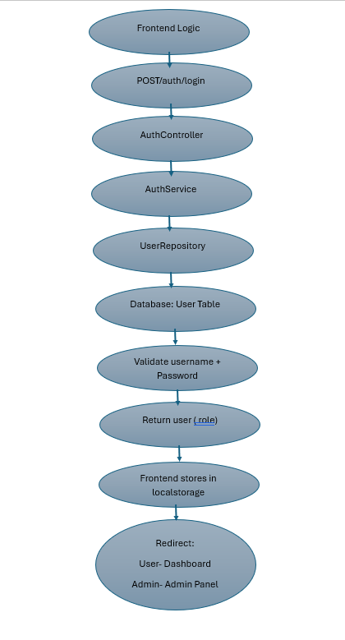

Register Page -
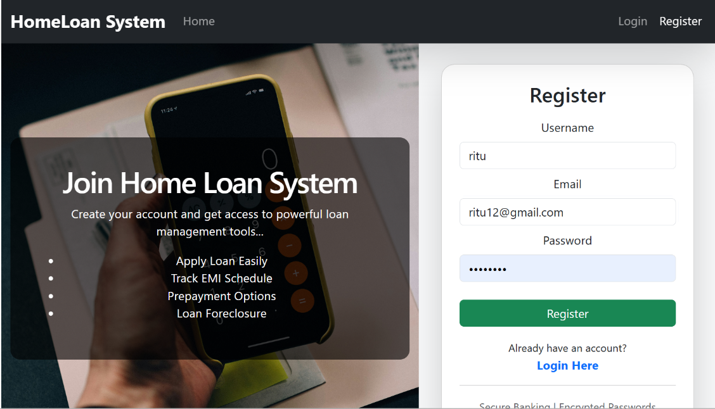
Login Page –
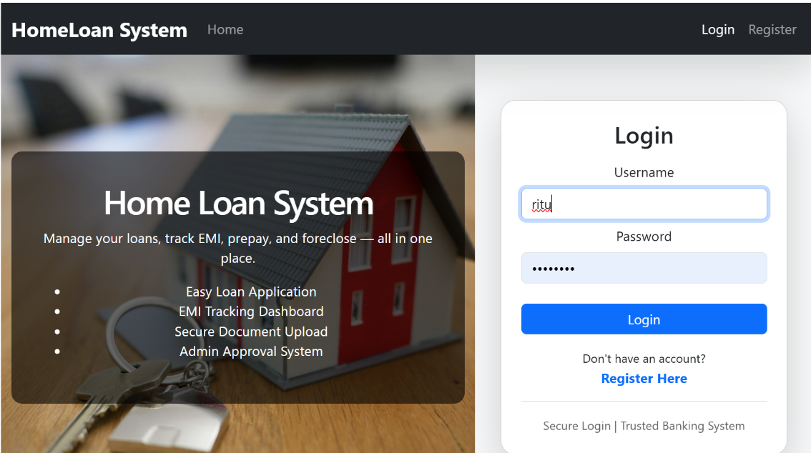

ACCOUNT CREATION FLOW (SIMPLE)
WHY THIS STEP?
After login, system must check:
- Does user already have a saving account

Login Success
Check Account (API)

Apply for loan
Create Account
Account Exists?

yes NO
apply

Dashboard

CREATE ACCOUNT PAGE-
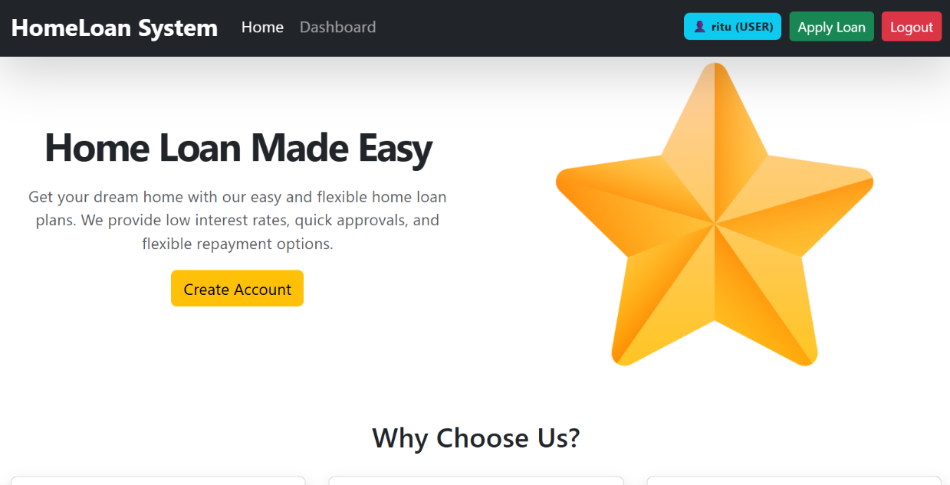
CREATE ACCOUNT-
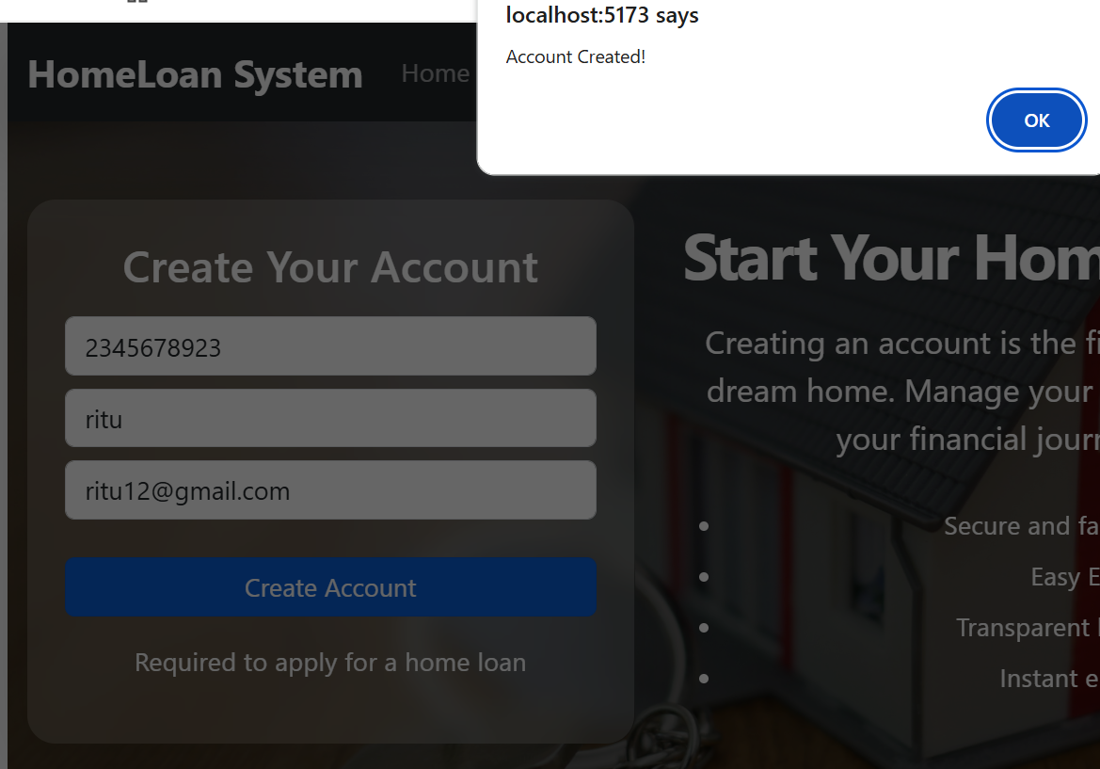

Create Bank Account (Frontend + Backend Logic):---
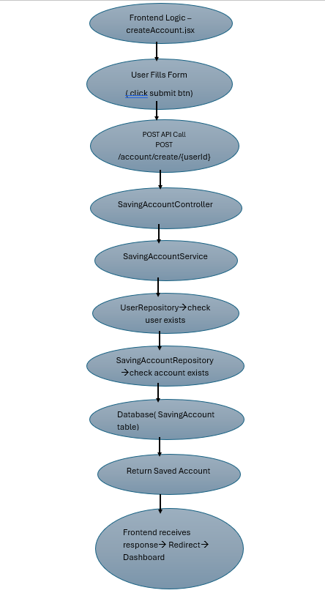

APPLY FOR LOAN (LOAN PAGE)-
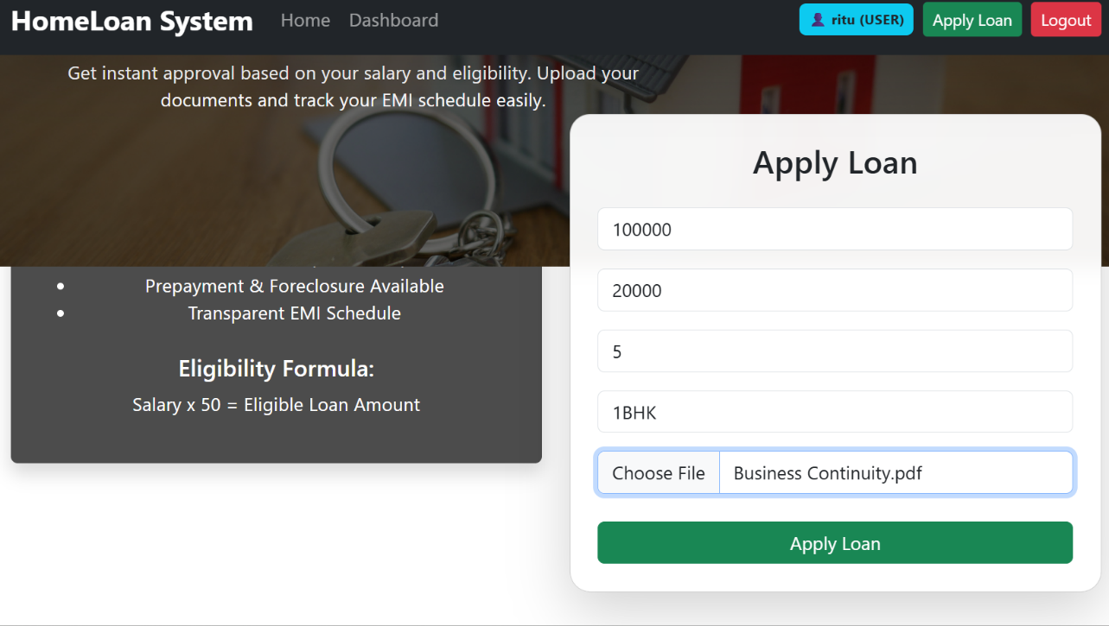

APPLY LOAN LOGIC:---

Step 1: User must have account
If account == null
→ "Create account first"

Step 2: Check active loan
If loan status = ONGOING
→ "User already has loan"

Step 3: Calculate eligibility
Eligible Amount = Salary × 50

Step 4: Decision
IF Requested Amount ≤ Eligible
→ Loan APPROVED
→ LoanAccount Created
→ EMI Calculated
→ Schedule Generated
ELSE
→ Loan Status = PENDING
→ Admin will decide

Prepayment Logic
- Reduce outstanding
- Recalculate EMI + schedule
Foreclosure
- Pay full outstanding
- Mark remaining as CANCELLED

ADMIN PANEL-

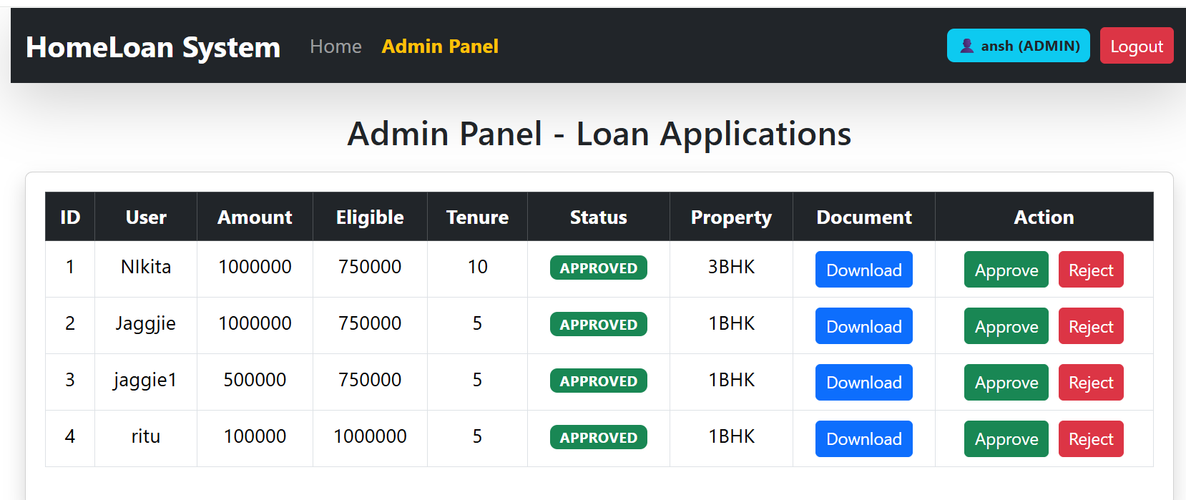

AFTER APPROVAL DASHBORAD PAGE –

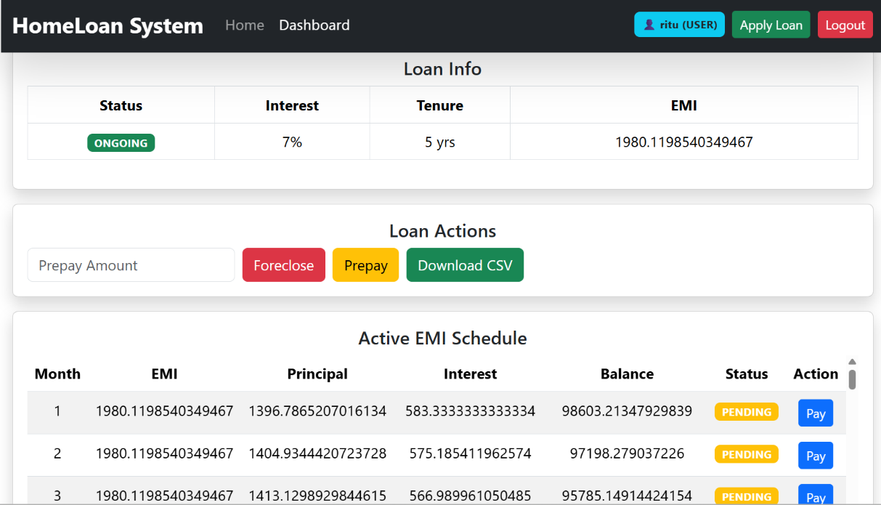

FLOW DIAGRAM OF APPLY LOAN

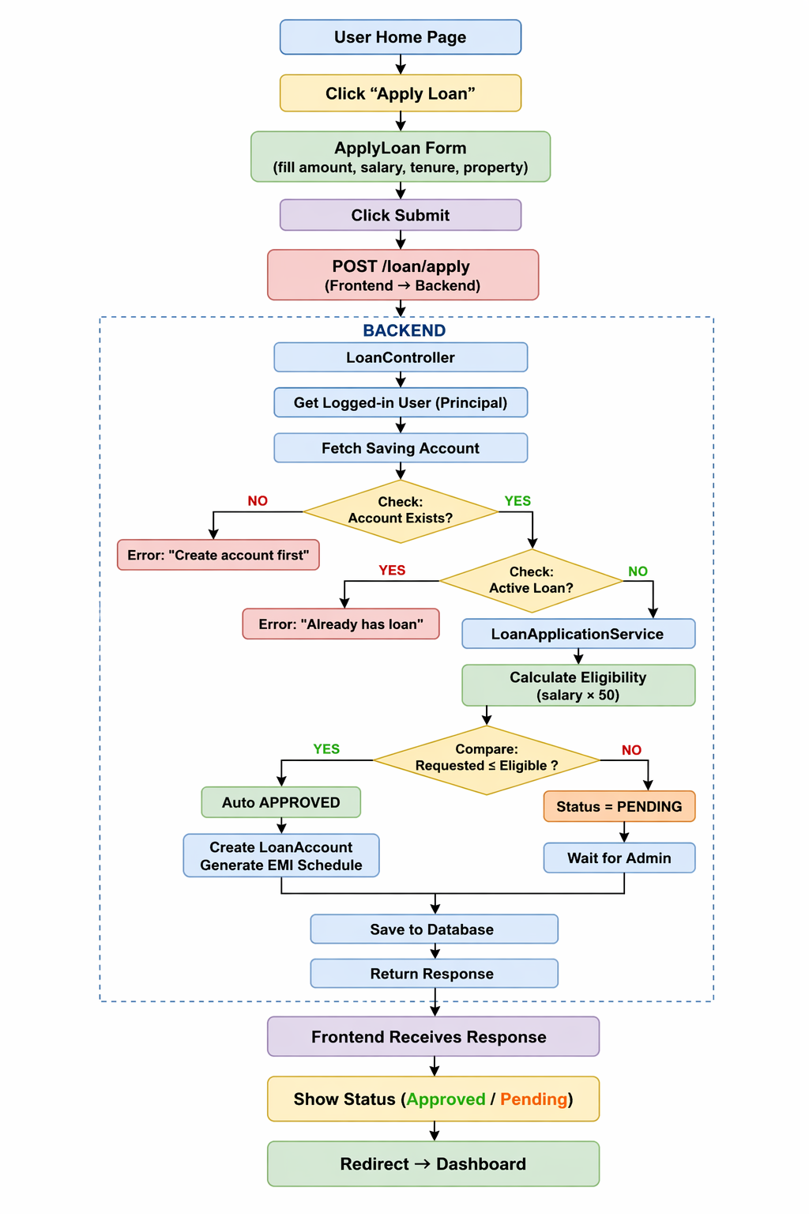

API CALLS –
Auth APIs
- POST /auth/register
- POST /auth/login

Account APIs
- GET /account/user/{userId}
- POST /account/create/{userId}

Loan APIs
Apply Loan
- POST /loan/apply
(multipart/form-data for file upload)

Loan Fetching
- GET /loan/{loanId}
- GET /loan/account/{accountId}
- GET /loan/schedule/{loanId}

Admin Loan Actions
- GET /loan/applications
- POST /loan/approve/{loanId}
- POST /loan/cancel/{loanId}
EMI & Payments
- POST /loan/pay-emi/{loanId}
Prepayment & Foreclosure
- POST /loan/prepay
(Body required: loanId + amount)
- POST /loan/foreclose/{loanId}
Export
- GET /loan/export/{loanId}
(Returns CSV file)

